1) What is operating system

Operating System lies in the category of system software. It basically manages all the resources of the computer. An operating system acts as an interface between the software and different parts of the computer or the computer hardware. The operating system is designed in such a way that it can manage the overall resources and operations of the computer. It is a fully integrated set of specialized programs that handle all the operations of the computer. It controls and monitors the execution of all other programs that reside in the computer, which also includes application programs and other system software of the computer. Examples of the operating system are Windows, Linux, Mac OS, etc.

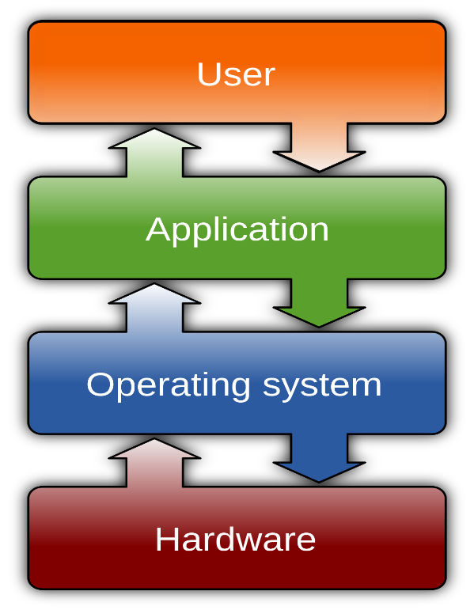

2)Types of operating system

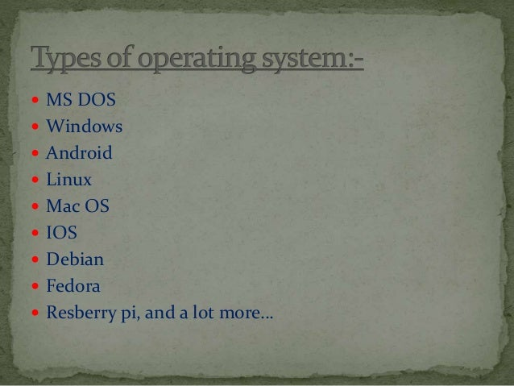

**What are the different types of Linux distributions?**

The different Linux distributions are often divided into three categories:

1 Full core Linux distributions

2 Specialized Linux distributions

3 Live CD test distributions

What is linux?

Linux was developed by linus torvalds in 1991. when he was the finnish student.

it is completely open source.

Torvalds as developed the kernal(linux is kernal based operating system)

Linux-kernal source code is written in the c lang.

The source code is freely avaialabel.

Torvalds has combined linux-kernal with GNU -----Linux operating system(kernal based).

Commands

-------

1.touch :- it is used to create the files .

Syntax :- touch <file-name>

touch <file1> <file2>

eg: touch harry

2.ls :- Display the list.

syn :- ls

3.mkdir :- It is used to create the directories.

syntax :- mkdir <dir-name>

eg: mkdir harika

4.cd :- change the directory.

syntax :- cd <dir-name>

5.cd .. :- to come out of the directory.

6.pwd :- It will print the present working Directory.

syntax :- pwd

7.whoami :- It will print /to know about the user name

syntax :- whoami

8.Editors :- to add the data inside the specific file.

vi, nano , vim

To save :- ctrl+s

to exit :- ctrl+x

9. cat: display the data

cat file :- It will display the data.

Syntax:cat > file ---- It will override the old data and it will save only new data

Syntax:cat >> file1 :- It will save the old data and adds the new data .

10.cp :- To copy the data from one file to other or files.

synatx :- cp source desti

cp -r :- to copy the entire directory.

syntax :- cp -r source dest

cp --copy.

-r -- recurisively

source :- from path

dest :- To where we need to copy.

11.mv :- to move the data from source to destination

synatx :- mv <source> <dest>.

*) To rename the file/directory

syntax :- mv <oldfile> <new-file name>

12.rm :- to remove the file(Delete)

synatx :- rm <file-name>

13.rmdir :- to delete the empty directory

syntax :- rmdir

14.rm -rf (remove -recurisively forcefully) :- to remove non empty directory

syntax :- rm -rf <directory-name>